

The Professional Education Center
Family Program
Standard Operating Procedures
(PEC-FP-SOP)

Revised: 20 September 2006

CONTENTS

SECTIONS PAGE

1. MISSION/PURPOSE………………………………………………………….… 3

2. GOAL …………………………………………………………………………… 3

3. VISION……………………………….……………………………………......... 3

4. MEMBERSHIP…………………………………………………………………. 3

5 PROGRAM SUCCESS…………………………………………………………. 3

6. VOLUNTEERISM………………………………………………………………….3

7. KEY STAKEHOLDERS ………………………………………………..….…… 3

8. WHO BENEFITS…………………………………………………….…..……… 4

9. ASSUMPTIONS ……………………………………………………….…..…… 4

10. PROGRAM RESPONSIBILITIES……………………………………………… 4

11. MEMBER EXPECTATIONS….…………………………………………...…… 5

12. PROGRAM FUNDING……………………………………………………...…… 5

ANNEXES

A. REGULATIONS, REFERENCES, RESOURCES……………........……. 6

B. SAMPLE PEC ANNUAL FAMILY PROGRAM SCHEDULE…………. 7

C. ORGANIZATION STRUCTURE……………………………….……….. 8

D. ROLES AND RESPONSIBILITIES……………………………….....….. 9

E. ORGANIZATION SYMBOLOGY…………………………………..…... 13

G. BEST PRACTICES……………………………………………………….. 14

1. MISSION/PURPOSE: The purpose of the National Guard Professional Education Center Family Program is to maintain and facilitate ongoing readiness, communication, involvement, recognition, and support between PEC and PEC Families in a partnership that promotes the best in each. The mission is to empower families to be self reliant and responsibly interdependent as they navigate the contingencies and challenges of PEC and military life.

2. GOAL: PEC will have a strong interdependent Family Program built around a functional and sustainable communication system focused on the three-pronged program:

a. Take care of the soldiers and their families,

b. Support interactive PEC Family activities for persons assigned to PEC,

c. Foster the NGB Family Program connection.

3. VISION: PEC to be the best tour of the Soldier and their family’s career.

4. PEC FAMILY PROGRAM MEMBERS: PEC Family Program members include the PEC Workforce, their families, and interested community members. Members potentially come from all 50 States, Territories, and the District of Columbia comprised of National Guard Title 10 soldiers, ADSW soldiers, Federal Employees, State Employees, Contractors, their families and friends. Members come together to serve the interests of PEC and PEC's families.

5. FAMILY PROGRAM SUCCESS: To date, PEC Family Program success is due to the level of support and involvement of the military and civilian staff and families. Due to this, program initiatives work to include the total PEC workforce needs and interests whenever possible.

6. VOLUNTEERISM: The intent of the PEC Volunteer Initiative is to empower PEC spouses to help one another while supporting the PEC mission, increasing family readiness programs and developing bonds within the PEC family.

a. Volunteer opportunities will include but not be limited to: PEC welcome wagon, PEC phone tree, PEC deployed soldiers family support, PEC event support.

b. The Commandant will provide full support of all volunteer initiatives.

7. KEY STAKEHOLDERS:

a. Command Group

b. Training Center and Division Chiefs

c. Family Program Sponsor, Staff, Advisors
d. Soldiers (Title 10 and ADSW)

e. Federal and State Staff

f. Contractors

g. Families of Military and Civilian

8. WHO BENEFITS:

a. Families

b. Military staff

c. Civilian staff & Contractors

d. The Community

e. PEC Command

f. TC/Dir Chiefs

g. The National Guard Professional Education Center

h. The Army National Guard Bureau

9. ASSUMPTIONS:

a. There are no ranks in a volunteer chain of concern.

b. Family Groups are NOT women’s groups, social clubs, nor welfare wagons.

c. The goal of the PEC Family Program is equality of services but provision of services will depend on individual, circumstances, contingencies and issues.

d. The PEC Family Program success is dependent on the level of support and involvement of the military, civilian staff and families. Active volunteerism is vital to the success of the PEC Family Program.

10. PROGRAM RESPONSIBILITIES:

a. Education and orientation

b. PEC activities and family involvement

c. Family sponsorship program (PEC Welcome Wagon)
d. Information, referral, and follow-up support services

e. Provide support and structure for PEC volunteer initiatives

11. MEMBERSHIP EXPECTATIONS:

a. Critical link between the Family Program, Training Center/Divisions and /or PEC families.

b. Two-way communication.

c. Active participation.

d. Support PEC FRG volunteer initiatives

12. PROGRAM FUNDING: Funding support is requested through non-appropriated fund (NAF) sources authorized by the Commandant. Annual funds allocated by the NAF for the PEC Family Programs operating expenses to be reviewed annually and at the discretion of the PEC Family Program Executive Council.

APPENDIX A: REGULATIONS, REFERENCES, RESOURCES

1. NGR 600-12 - National Guard Family Program - 8 January 1986

2. DD Instruction 1342.23 - Family Readiness in the National Guard and Reserve Component - September 29, 1994

3. DA PAM 608-47 – A Guide to Establishing Family Support Groups – 16 August 1993

4. FORSCOM 500-3-3 – Volume III Reserve Component Unit Commander’s Handbook – 15 July 1999

5. AR 600-20 – Army Command Policy – 1 February 2006

6. AR 608-47 - Army Family Action Plan (AFAP) Program – 14 December 2004

7. AR 608-48 – Army Family Team Building (AFTB) Program – 28 March 2005

8. The Army Family Readiness Handbook – Operation READY – 1994

9. Army Leaders’ Desk Reference for Soldier/Family Readiness – Operation READY – 2002

10. Army Family Readiness Group Leaders Handbook – 2002

11. Guard & Reserve Family Readiness Programs Toolkit – 2004

APPENDIX B: SAMPLE PEC ANNUAL FAMILY PROGRAM SCHEDULE

PEC Family Program | Sep | Oct | Nov | Dec | Jan | Feb | Mar |  | Apr | May | Jun | Jul | Aug
Fall Race for the Cure |  |  | X
Fall Harvest Festival “Fall Fest” or Organization Day |  |  | X
Holiday/Christmas Dinner |  |  |  | X
Spring Easter Egg Hunt |  |  |  |  |  |  |  |  | X
Fiesta & Salsa Competition |  |  |  |  |  |  |  |  |  | X
Summer Wild River Country Afternoon |  |  |  |  |  |  |  |  |  |  | X
Educational Opportunity (PEC Family Conference with GFTB learning):  - Individual learning on-line or on-site: Stress Management, Leadership, Problem Solving, Military 101, etc.  - Instructor Training - TBD |  | → | → | → | X  (Jan or Feb: PEC Workshop, Conference, or Training) |  |  | → | → | → | →
NGB Family Program Conference |  |  |  |  |  |  |  |  |  |  |  | X
OPERATIONS:
- PEC FRG Meetings | X | X | X | X | X | X |  | X | X | X | X
- FP Executive Council Meeting (TBD) |  | X

APPENDIX C: ORGANIZATION STRUCTURE
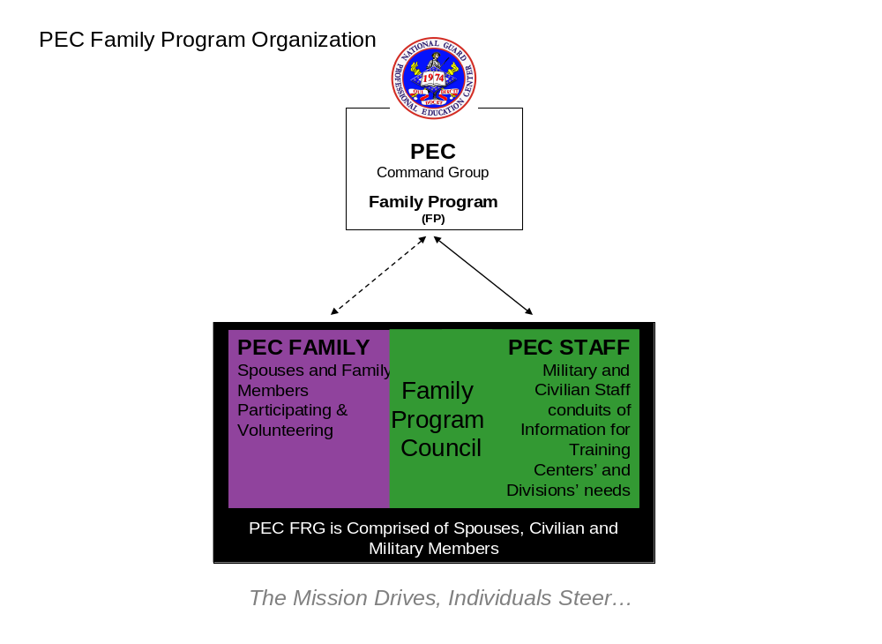

APPENDIX D: ROLES AND RESPONSIBILITIES

1. PEC COMMANDANT

a. Develop and implement a comprehensive Family Program that supports the needs of the Professional Education Center and the Army National Guard.

b. Approves of PEC Family Programs and Family Program Goals, Objectives, and Initiatives and provides guidance, as needed.

c. Identify a coordinator to be designated as the Family Program Coordinator.

d. Ensure that program standards as outlined in NGR 600-12 are effectively implemented.

e. Identify fiscal and/or manpower resources requirements for the family program as approved or as otherwise required.

f. Encourage command support of the program.

g. Emphasize the importance of the family and the Family Program and support PEC and family member participation in activities sponsored under the Family Program.

h. Recognize the importance of volunteer staff and supports their effort within the Family Programs initiatives.

2. FAMILY PROGRAM SPONSOR (S1)

a. Serve as the military liaison for the PEC Commandant in all matter pertaining to the Family Program and/or Family Readiness Group.

b. Encourage command support of the Family Program.

c. Emphasize the importance of the family and the Family Program and support PEC and family member participation in volunteerism activities sponsored under the Family Program.

3. PEC TRAINING CENTER/DIVISION CHIEFS

a. Implement the Family Program.

b. Provide resources to the Family Program.

c. Emphasize the importance of the family and the Family Program and support PEC and family member participation in activities sponsored under the Family Program.
d. Encourage Training Center/Division volunteer participation in Family Readiness Group initiatives.

e. Refer deployed Soldiers and families to ensure readiness.

4. TRAINING CENTER/DIVISION FAMILY PROGRAM REPRESENTATIVE (appointed staff and volunteer spouses)

a. Assist in two-way communication between Training Centers/Divisions, Family Program, Command Group and PEC families.

b. Welcome Training Center/Division new soldiers/civilian staff and families to PEC and assist them in getting integrated into the Family Program network.

c. Encourage participation and volunteer involvement in Family Program meetings and activities.

5. FAMILY PROGRAM COUNCIL (includes Training Center/Division Chief or designee and Family Readiness Group representatives)

a. Provides advice to the Command Group.

b. Identifies resources to ensure the Family Program initiatives are achieved

c. Meets annually to:

(1) Validate the Family Program schedule.

(2) Identify Training Center and Division event sponsorship.

(3) Provide resources.

(4) Identify a contributing training center/division representative for Family Program functions and to attend meetings.

(5) Identify current and future Family Program needs.

d. Helps to resolve identified issues and interests.

e. Encourage volunteerism within Training Centers and Divisions.

6. FAMILY PROGRAM COORDINATOR

a. Serve as Family Readiness Coordinator for PEC family programs and activities serving more than 350 PEC staff families.
b. Provides guidance to the PEC Military Sponsor, PEC families and leadership to develop and execute plans of action to meet goals and objectives. Act as information and referral source for military families.

c. Coordinate resources as needed to assist with military family concerns, provide training and information to assist families.

d. Initiates correspondence, floral expressions, cards and memorandums in response to PEC family situations and concerns in accordance with funding provided in the NAF-SOP.

e. Ensure all families served by the PEC FRG are aware of pertinent information such as meetings, family activities, or other events.

f. Conduct briefings for incoming soldiers and/or family members to include a welcome packet. Coordinate, support and facilitate monthly FRG meetings.

g. Maintain current family directory. Prepare informational deployment packet for spouses of PEC soldiers in pre-deployment status and coordinate Soldier/spouse deployment briefings.

h. Serve as PEC liaison to the National Guard Bureau Family Readiness Office and PEC Commandant. Time recommended for task order is at 25%.

7. FAMILY PROGRAM ADVISOR (members include the Commandant’s spouse, the CSM’s spouse and a civilian staff member appointed by the Commandant)

a. Provide strategic guidance and outline objectives for the PEC Family Program.

b. Serve as PEC public/community liaison.

c. Encourage participation and volunteer involvement in Family Program meeting and activities.

8. THE FAMILY READINESS GROUP (FRG) (consists of PEC workforce, families and other interested parties)

a. Encourage participation and volunteer involvement in Family Program meetings and activities.

b. Attend scheduled meetings.

c. Volunteer as needed.

d. Provide emotional support to one another.

e. Help identify needs and services.

f. Help resolve issues in an effort to assist the families of PEC.

g. Ensure National Guard member keep the appropriate mobilization documents and required emergency data updated in their military files to care for their families.

h. Support assigned members of their Training Center/Division as requested by the respective Chief or Commandant.

i. Encourage PEC workforce to forward information and messages to their families in support of the Family Program.

j. Keep family informed of key personnel information, benefits, programs, etc.

APPENDIX E: ORGANIZATION SYMBOLOGY

1. FEATHER. The PEC Family Program embraces the FEATHER as a symbol because:

a. Feathers have historically been displayed by leaders acknowledge accomplishments and achievements. The PEC feather reminds us that we are leaders of ourselves, our homes, our families, and our communities. It is in recognition of our pursuit of balance and wellness.

b. Feathers given as a symbol of kindness with the intent that this kindness will continue in forward flight from giver to receiver with the hope that kindness will return to the original giver.

c. Feathers attached to the PEC pin indicate you are one of the PEC Family Program…as, “Birds of a feather flock together.”

2. AWARDS AND RECOGNITION. A birdhouse or a feather fossil is awarded to members at FRG meetings, PCS and retirement ceremonies.

a. The Feather Fossil is presented by the PEC Family Program of the National Guard Professional Education Center for dedication to PEC in an effort to embed forever PEC Family memories.

b. The Birdhouse is presented by the PEC Family Program of the National Guard Professional Education Center for dedication to PEC and in appreciation of significant contributions to the PEC Family Program.

APPENDIX F: BEST PRACTICES

1. Care for Soldiers / Families
a. Support
(1) Volunteerism
(2) Correspondence: notes, cards, email
(3) Face-to-Face Contact
(4) Phone Calls
(5) Welcome Packs
(6) Solutions for Individual needs: Adopt an Animal, PAR Project (Photo-and-Recipe Project), Knight Easter Baskets, etc.
(7) Activities for PEC Family Fellowship
b. Recognition
(1) Town Hall Meetings
(2) Commandant Coins
(3) Certificates
(4) Newsletters
(5) Emails
(6) Website
(7) Meetings
(8) TC/Dir, Military/Civilian, Families, Interested Parties
(9) PCS Feather Fossil & Birdhouses
c. Empowerment
(1) Distribute Relevant Information: PEC, NGB, AR, etc.
(2) Facilitate Interaction: Activities, Meetings, Volunteer Opportunities, etc.
(3) Provide Learning Opportunities. (e.g. PEC Tour, Conference, Guard Family Team Building)
(4) Assist folks with individual efforts to be self sufficient and responsibly interdependent.
d. Support Deployed/Extended TDY Soldiers & Families
(1) Preparation
(2) Pre Assignment
(3) During Assignment
(4) Post Assignment
2. Potential PEC Activities
a. Potential Activities by Scale:
(1) Large Scale:
(a) Holiday Dinner
(b) Fall Fest or Organization Day
(2) Medium Scale:
(a) FP Conference (Ed & Training)
(b) Spring Fiesta & Salsa Competition
(3) Small Scale:
(a) PEC Tour
(b) Fall - Race For The Cure
(c) Winter - Chili Cook-Off
(d) Spring Easter
(e) Summer Water Park
(4) Other Miscellaneous Activities (e.g. Special Opportunities: Community Tours, Guard Family Team Building, Guard Family Action Plan, etc.)
b. Activity Support Includes:
(1) Maintain Project Book Checklists
(2) Maintain Project Book After Action Reports (AAR)
(3) Activity Consultation
(4) Activity Specific Support (TBD by Activity Lead and FP Coordinator)
3. Sustain NGB Link
a. Attend NGB National Family Program Conference
b. Leverage Program Opportunities (e.g. Guard Family Team Building, Guard Family Action Plan, and Army One Source)
c. Maintain NGB communications
4. Build a Sustainable Program
a. Organization Symbology
b. Charter
(1) Mission/Purpose
(2) Membership
(3) Responsibilities
(4) Meetings
c. Facilitate Communication & Network
(1) Newsletters
(2) Meetings
(3) Email Distribution
(4) Website: www.NGPEC-Family.org
(5) Activities
(6) Awards/Recognition

